Simcoe County Data Consortium
TERMS OF REFERENCE 2012-2017 FINAL DRAFT
Last Revised: October 2012

INTRODUCTION
The Simcoe County Data Consortium is led by the County of Simcoe, with input from its member agencies. The Simcoe County Data Consortium is guided by the philosophy of the Community Data Program, which serves as a gateway for municipalities and community sector organizations to access customized tables from Statistics Canada and other providers to monitor and report on social and economic development trends within their communities.

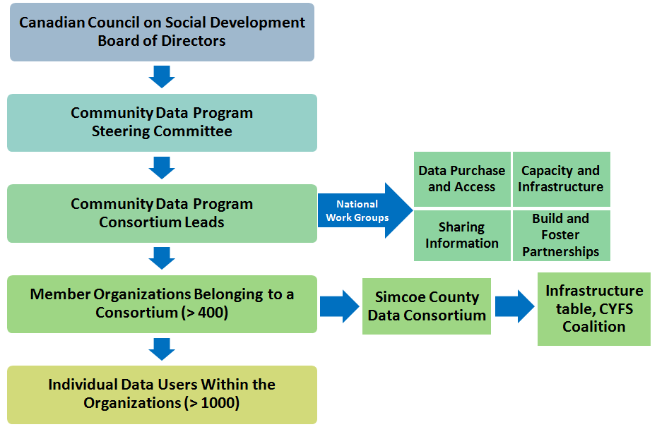

PURPOSE
The purpose of the Simcoe County Data Consortium is to coordinate access to community data based on the needs of local Consortium Members and their agencies, as well as provide a venue for collaboration on local community research activities.

FUNCTIONS
- Develop a collective understanding of community trends and issues;
- Facilitate access to summarized and raw data products, such as through the Community Data Program;
- Coordinate and leverage local data mining opportunities;
- Determine the community data needs of members;
- Identify and facilitate data training opportunities;
- Network and share information about member activities/initiatives;
- Work collaboratively and reduce duplication of effort;
- On an annual basis, identify mutually beneficial research projects and develop workplans for their development;
- Broadly disseminate local community trends and issues.
MEMBERSHIP
Simcoe County Data Consortium Members are comprised of community based agencies with an interest in social research. Membership includes, but is not limited to, members of the Children, Youth and Family Services Coalition of Simcoe County.

Data Users are considered to be Simcoe County Data Consortium Members that are formally registered with the Community Data Program, and thereby have access to the Community Data Program catalogue and services. Data Users’ agencies are listed in Schedule A of the Memorandum of Agreement, and have signed the appropriate Schedules in the MOA (including the licensing agreements).

SUBCOMMITTEES
Ad hoc working groups will be developed as needed.

ROLE OF CHAIR
As the lead Consortium agency, and signatory of the 2012-2017 Memorandum of Understanding with the Canadian Council on Social Development, the County of Simcoe will act in the position of Chair. The responsibilities of the Chair will include the planning and coordination of local meetings, the distribution of meeting minutes, and providing regular updates on the national Community Data Program to Consortium members.

ROLE OF MEMBERS
- To participate with members of the Consortium to set directions and priorities for mutually beneficial research projects;
- To provide input in the decision-making process of the local Consortium;
- To actively participate in the Data Consortium;
- To provide regular updates on the Consortium’s progress to their member agencies;
- To identify any changes to the minutes to the Chair;
- To abide by the licensing agreements on the signed Schedule.

REPORTING
Reports on Data Consortium activity will be provided to the County of Simcoe, the national Community Data Program and/or the CYFS Coalition, as requested. Approval for any specific project undertaken will be sought by the appropriate party, if additional authorization is required.

MEETINGS
Meetings will be held quarterly and meeting dates will be set in advance annually. A meeting agenda will be provided prior to the meeting. Note-taking responsibilities will be shared among members. Additional meetings will be arranged as required.

COMMUNICATION
Minutes are distributed to the membership of the Simcoe County Data Consortium via email and posted online for access by stakeholders.

REVIEW
These Terms of Reference will be reviewed every five years (in alignment with the MOU contract schedule).

