TERMS OF REFERENCE

Simcoe/Muskoka

Transition Age Youth System of Supports partnership

Vision
Transition Age Youth (TAY) will receive services that are inclusive of all in preparing and facilitating them in their movement toward greater self-sufficiency and successful achievement of their goals related to relevant transition domains (i.e. employment/career, educational opportunities, living situation, personal effectiveness/wellbeing and community life functioning.).

Goal
TAY in Simcoe/Muskoka will have the opportunities and resources they need to grow into responsible, contributing adults.

Mandate
To plan, implement, monitor and evaluate a Simcoe/Muskoka System of Supports for Transition Age Youth.

Scope
The TAY SoS Partnership is dedicated to creating a comprehensive integrated system of supports that assists youth/young adults 14 to 29 years old and their families through the transition to adulthood. The scope of the initiative is intended to be as broad as possible for this age range, covering the spectrum of health, education, employment, community and social supports.

Guidelines
The following seven Transition to Independence Process (TIP) Model system guidelines are the foundation for the TAY system of supports across Simcoe County:
1. Engage young people through relationship development, person-centered planning, and a focus on their futures.
2. Tailor services and supports to be accessible, coordinated, linguistically and culturally sensitive, appealing, non-stigmatizing, and developmentally-appropriate -- and building on strengths to enable the young people to pursue their goals across relevant transition domains.
3. Acknowledge and develop personal choice and social responsibility with young people.
4. Ensure a safety-net of support by involving a young person’s parents, family members, and other informal and formal key players.
5. Enhance young persons’ competencies to assist them in achieving greater self-sufficiency and confidence.
6. Maintain an outcome focus in the TAY system at the young person, program, and community levels.
7. Involve young people, parents, and other community partners in the TAY system at the practice, program, and community levels.

Objective
The TAY SoS Partnership is designed to give young people in Simcoe/Muskoka the best possible transition to a successful adulthood. The TAY SoS Partnership will support the development of an integrated system of supports for transition age youth that is seamless and builds on existing community resources.

In order to achieve the identified objective, the TAY SoS Partnership will:
- Engage in collaborative community planning that promotes implementation of the TIP Model across all sectors
- Establish and support (or direct, as required) effective structures required to implement the TAY Partnership Vision.
- Build effective partnerships with young people, and their families/support networks, to promote implementation of the TAY Partnership Vision.
- Receive, review and advise on impacts of system initiatives, provincial legislation, regulation and available data as it relates to the TAY Partnership Vision.
- Act as a common voice for TAY Service Providers in Simcoe County.
- Advocate for TAY Service Providers in Simcoe County.
- Actively support youth engagement at all levels of the TAY system of supports.
- Evaluate and monitor the TAY System of Supports including Implementation and fidelity of TIP Model.

The integrated system of supports will serve:

Transition Age Youth by:
  - Engaging young people in their own futures planning process
  - Providing them with developmentally appropriate, non-stigmatizing, linguistically and culturally sensitive, and appealing services and supports
  - Involving them and their families and other informal key players in a process that prepares and facilitates youth in their positive movement to adulthood
  - Involve youth and families as key partners in service planning, service delivery, and evaluation

Service providers by:
1. Improving collaboration with other TAY serving services
2. Increasing sense of competency and job satisfaction of direct service providers

Partnership by:
1. Having a common vision, common guidelines, common tools, and a common language for working with youth/young adults
2. Having an emphasis on collaborative processes and application of best available practices in service planning and delivery

Accountabilities
The TAY SoS Partnership will report to the North Simcoe Muskoka LHIN via the Child and Adolescent Mental Health and Addictions Steering Committee and the Child, Youth and Family Services Coalition of Simcoe County through the Planning Table.

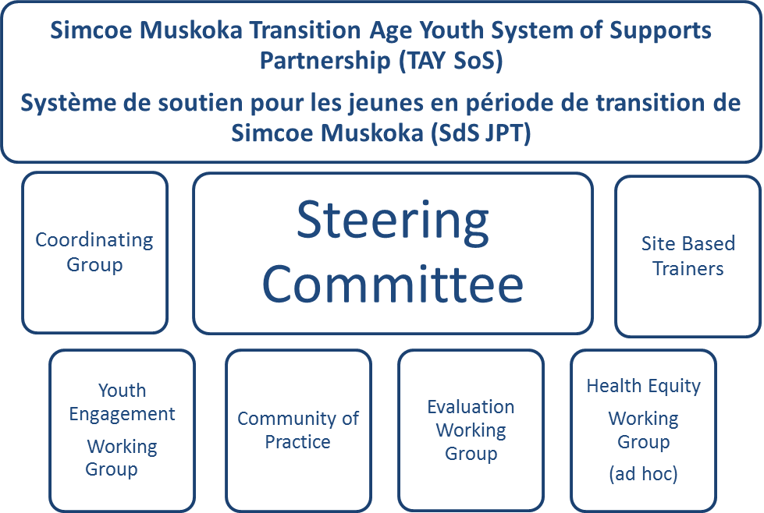

Roles and Responsibilities
The TAY SoS Partnership will reflect the unique composition of our community and a broad range of community perspectives as suggested in the list below. It is important that participants are able to make decisions on behalf of the organization and/or sector they represent.

Membership:
- AIDS Committee of Simcoe County
- ACBC /BANAC (Barrie Area Native Advisory Circle)
- Centre for Addiction and Mental Health
- Canadian Mental Health Association – Simcoe County
- Canadian Mental Health Association –Muskoka Parry Sound
- Catulpa Community Support Services
- Chigamik Community Health Centre
- College Boreal
- Community Living Huronia
- Community Living Huntsville
- Conseil Scolaire de District Catholique Centre-Sud (French Language Catholic School Board)
- Conseil Scolaire Viamonde (French Language Public School Board)
- Elizabeth Fry Society
- Enaahtig Healing Lodge and Learning Centre
- Entite 4
- Family, Youth and Child Services of Muskoka
- Families through the Family Council
- Georgian College
- Hands the Family Health Network
- Kinark Child and Family Services
- La Clé
- Métis Nation of Ontario
- Muskoka Parry Sound Community Mental Health Service
- New Path Youth and Family Services
- Ontario Works
- Patient/Client and Family Council
- Quest Collegiate
- Royal Victoria Hospital
- Simcoe Community Services
- Simcoe County Children’s Aid Society
- Simcoe County District School Board
- Simcoe Muskoka Catholic District School Board
- Simcoe Muskoka District Health Unit
- South Georgian Bay Community Health Centre
- The Next Door
- Trillium Lakelands District School Board
- Waypoint Centre for Mental Health Care
- YMCA of Simcoe Muskoka
- YWCA Muskoka
- Youth Justice Ontario
- Youth Haven
- Youth through the Youth Council
- Other groups as identified

Co-Chairs:
The Co-chairs are elected to ensure stability and continuity for the TAY SoS Partnership. One Co-chair position will be filled by a member of a LHIN funded agency.

The Co-chairs of the Steering Committee are responsible for recommending actions for consideration by the Partnership, and keeping the Steering Committee updated on the activities of TAY SoS Partnership

The chairs are spokespeople on behalf of the committee, but not specific groups.

It is the role of the Co-chairs to:
- Participate actively in all meetings and work of the Partnership
- Ensure that minutes and motions of each meeting are distributed appropriately
- Chair the meeting in a fair and efficient manner, including starting and adjourning meetings on time
- Ensure tasks assigned are addressed within the specified time-frame established
- Ensure the minutes reflect points of discussion and record major decisions
- Provide an opportunity for all members of the Partnership to participate in the discussions
- Participate on Working Groups
- Provide updates/presentations to community planning groups including Coalition and LHIN
- Liaise with/participate on Simcoe/Muskoka LHIN Child and Adolescent Mental Health and Addictions Steering Committee

Length of Co-Chair term: Two year term up to two terms for a maximum of four years.

role of the past co-chairs:
The Past Co-Chairs provide continuity to the work of the TAY SoS Partnership.
The most recent past co-chair assumes responsibilities as assigned in the absence of a present co-chair. Co-Chairs must consist of one adult agency and one youth agency. At least one co-chair must be LHIN funded.

Role of Members:
In conducting the key activities of the TAY SoS Partnership it is expected that the members of the Partnership will:
- Conduct business in the best interest of TAY in Simcoe/Muskoka
- Act in an impartial manner
- Be prepared for each meeting by reviewing information in advance
- Participate in all committee meetings or send a designate if available
- Ensure that relevant TAY SoS Partnership information is shared throughout their agency
- Commit to strengthening youth and family engagement in their agency

Evaluation of the tay partnership:
The performance of the TAY SoS Partnership and implementation of the TIP Model will be evaluated by the TAY SoS Evaluation Workgroup.

Meeting frequency:
The TAY Partnership Steering Committee will meet bi-monthly for two hours at a time (s) that the majority of members are able to attend.

Decision-Making process and dispute resolution:
Members are to ensure that they are not in conflict of interest by speaking in favour of, or recommending a course of action that may benefit them personally, and that may not be in the best interests of the communities. Members must disclose when they are in conflict of interest and remove themselves from voting.

Decisions will be made, whenever possible, through consensus. When consensus is not possible, the co-Chairs shall call for a vote requiring a 2/3 of the present membership.

Timeframe for review
The TAY SoS Partnership will review the Terms of reference annually in June.

From Simcoe/Muskoka Service Collaborative Project Charter
From Transition of Youth and Young Adults with Emotional or Behavioral Difficulties: An Evidence-Supported Handbook p49.

