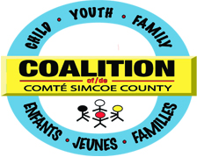
CYFS Coalition Planning Table
Rotating Schedule for Networks and Task Groups 2015*

Month | Task Group | Network
September 2015 | None – review of remaining TTC reports  None – review of remaining TTC reports
October 2015
November 2015 | Fetal Alcohol Syndrome Disorder (FASD)  Autism Spectrum Disorder (ASD)
December 2015 | Aboriginal Capacity Building Circle (ACBC) | COMPASS, Francophone COMPASS
January 2016 | Basic Needs Task Group (BNTG) | Children’s Treatment Network (CTN)
February 2016 | Dual Diagnosis  Integrated Working Task Group if active
March 2016 | Youth Justice Advisory Group (YJAG) | TAY SoS
April 2016 | LEAP (learning, earning and parenting)  Father Involvement Group
May 2016 | Triple P (Positive Parenting Program) | Best Start
June 2016 | Crisis Steering Committee -(Suicide Risk Protocol)  Wraparound

- Working Tables and Networks - Please refer to below Addendum Group Presentation to Planning Table (FINAL Process) 2015 for guidelines, requests of support or presentation to Planning Table
- 

