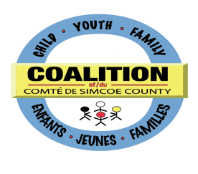
PLANNING STRATEGY TABLE MEETING

June 10, 2014, 1:30-4 p.m.
The Common Roof (165 Ferris Lane, Barrie)

MINUTES
Present:
Bernard, Sylvia | Cole, Sandra (Co-Chair) | Watson, Mary Jean (Co-Chair)
Blue, Danette | D’Ambrosio, Lora  Jackson, Brenda | Woods, Deb
Clarke, John | McKeeman, Elizabeth | Veenstra, Kristina (recorder)
 | Thurston, Sandy
Regrets:
Byrch, Ligaya |  | Harris, Jim
Carney, Pat Dr. | Dooley-Phillips, Geraldine | Martins, Nadia
Cascagnette, Fiona | Forrest, Gisele | Simmons-Physick, Christine

Guests: Gail Hamelin, Kinark and Gwen Bennett, SMDHU

Thanks to The Common Roof for hosting today’s meeting.

- Welcome: Roundtable Introductions
Roundtable introductions were done.

- Approval of Minutes November 12, 2013
Minutes approved as circulated.

- Approval of Agenda

Agenda approved as circulated with shortening of Strategic Planning item to 10 minutes and addition of feedback aboutDeb and Kristina’s time from business arising out of the previous meeting.

NEXT MEETING:
Tuesday, January 14, 2014
1:30-4 p.m
The Common Roof, 165 Ferris Lane, Barrie

